**Layout of the model**

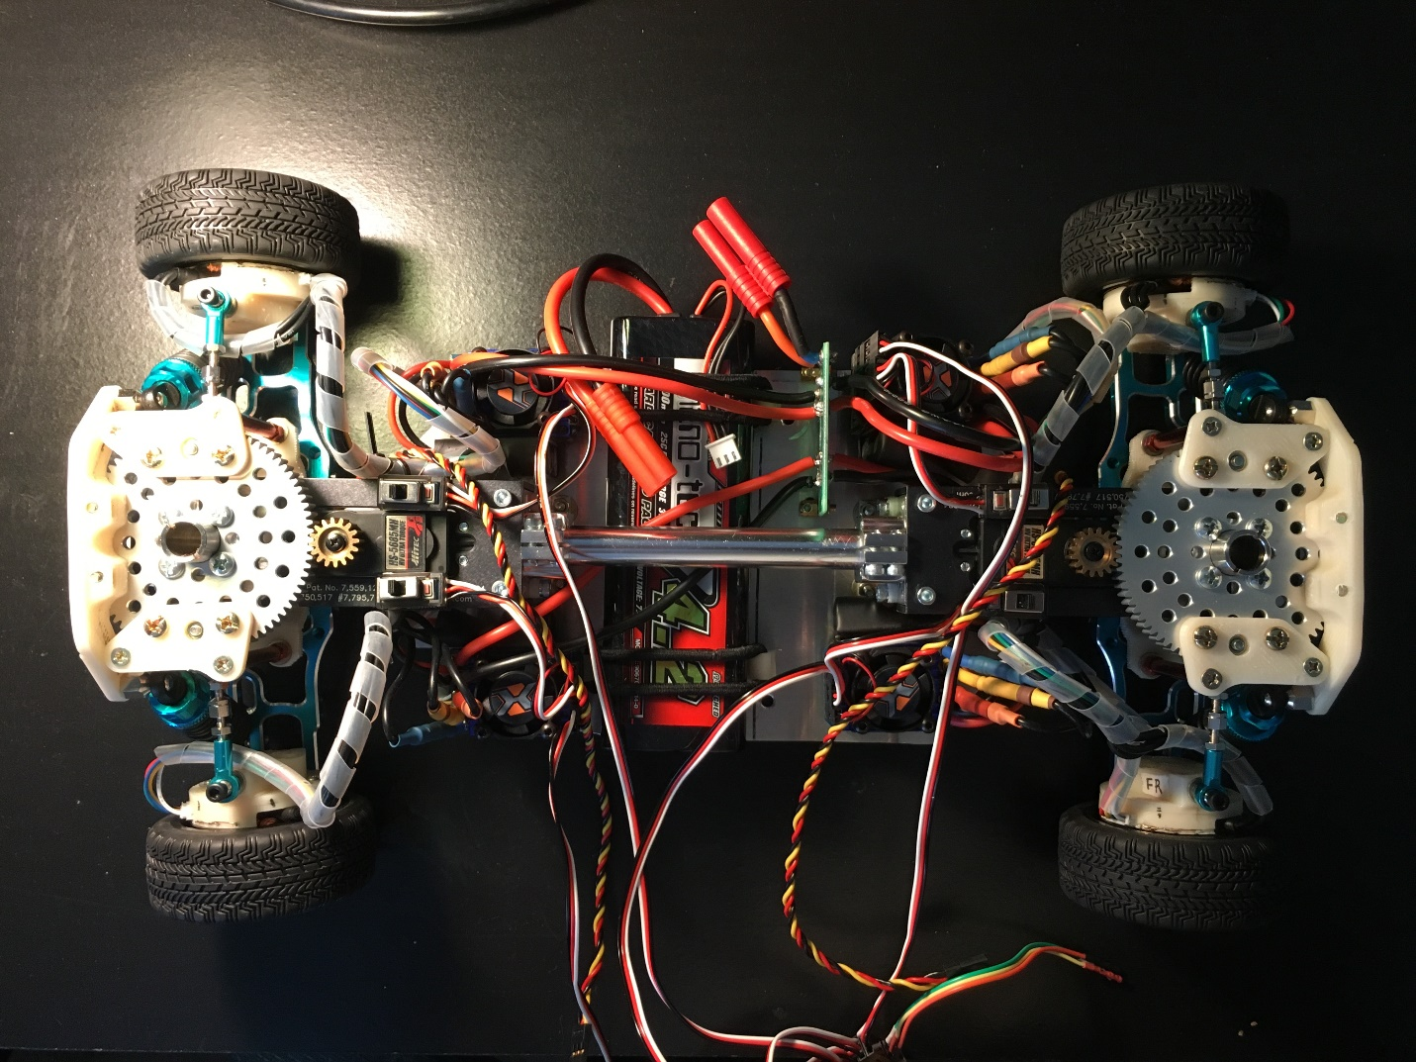

Wheel Motor

Wheel Base: 292.10mm

Wheel Track: 193.02mm

Overall Length: 388.07mm

Overall width: 220.07mm

Overall height: 94.04mm

Front Steering servo

Wheel Motor

Wheel Motor

Wheel Motor

Power Hub

Battery

ESC-Electronic Speed Controller

**Sketch of the circuit of the power assembly**

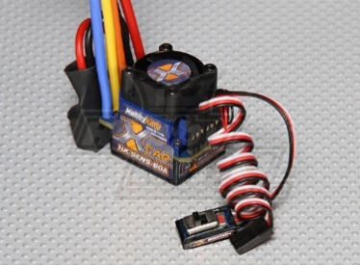

JST-ZH 6Pin Connector

3.5 mm Gold Connector

Switch



JST-ZH 6Pin Connector

3.5 mm Gold Connector

Switch



JST-ZH 6Pin Connector

3.5 mm Gold Connector

Switch

4 mm Gold Connector

 When reconnect the brushless motor’s 3.5 mm gold connectors, make sure to match the wires with the same color (Black wire is wrapped by the color shrink tube at the connector).



JST-ZH 6Pin Connector

3.5 mm Gold Connector

Switch

**Servo**

* The wire definition of the servo cables of the typical brands. The servo on the prototype 1 is the HITEC: HS-5685MH.

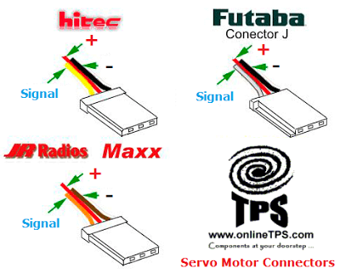

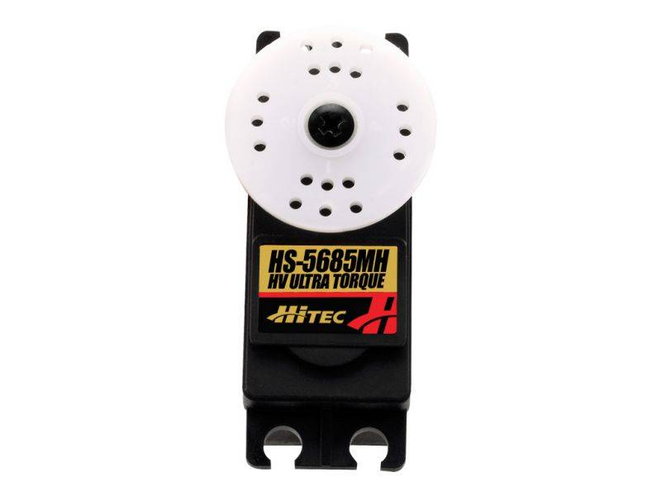

* Input to the servo.
  + 4.8v-7.4v DC for power supply
  + 4.8v-7.4v 50Hz Square wave signal input
* Output of the servo.
  + 11.3 kg·cm, 0.2 sec/60°at 6v power supply.
  + 12.9 kg·cm, 0.17sec/60°at 7.4v power supply.

**Steering system**

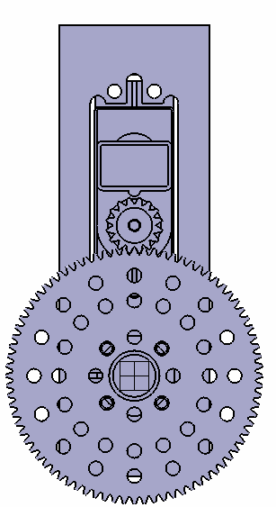

Steering angle sensor

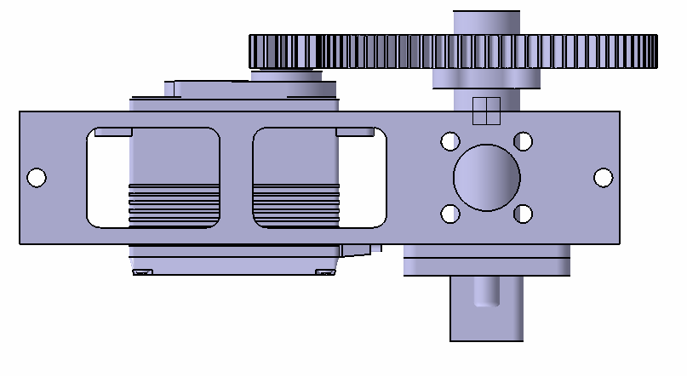

* Since a 1:5 gear reduction is added to the servo, the output of the steering system,
  + 56.5 kg·cm, 1 sec/60°at 6v power supply.
  + 64.5 kg·cm, 0.85sec/60°at 7.4v power supply.
* Control signal
  + 50Hz(20ms) square wave
  + Center position: 7.5 % (1.5ms), Positive 45°: 10 % (2ms), Negative 45°: 5% (1ms).
  + Rotation limit: ±30°- duty cycle limit: 5.83% (1.165ms) ~ 9.17% (1.835ms).
  + The holes can be used as reference if you need to calibrate the PWM signal.

22.5 °

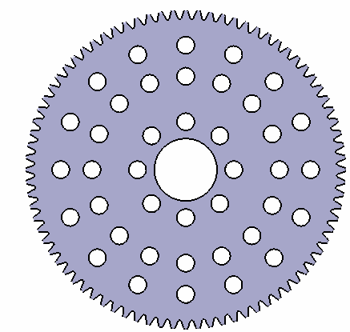

**ESC – Electronic Speed Controller**

* A 6v DC-DC is embedded into the ESC.
  + The DC-DC is originally used for powering the receiver and servos.
  + When you have an external power supply, don’t connect the red wire to it.
  + If you use one PWM signal to control multiple ESC, don’t connect red wires together.
* Signal
  + The same signal requirement as the servo.
  + Neutral: 7.5 % (1.5ms), forward: 7.5% (1.5ms) ~ 10 % (2ms), reverse: 7.5% (1.5ms) ~ 5% (1ms).
  + Electronic brake is applied when signal is switched from forward to reverse. When the signal is switched from reverse to forward, the motor will change the direction immediately and drain large current, avoid this situation.
  + The reverse will only be enabled when signal stays on the neutral for 2 second.

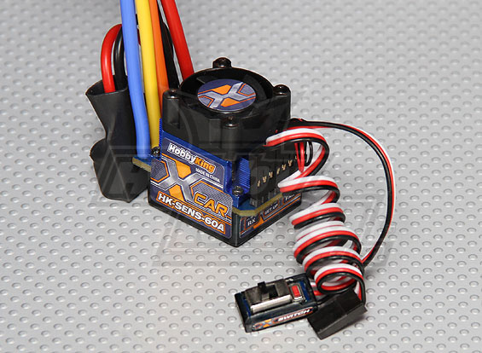

Hall-Effect sensors port

To motor

Ground

DC-DC output

Signal

Battery in

Switch

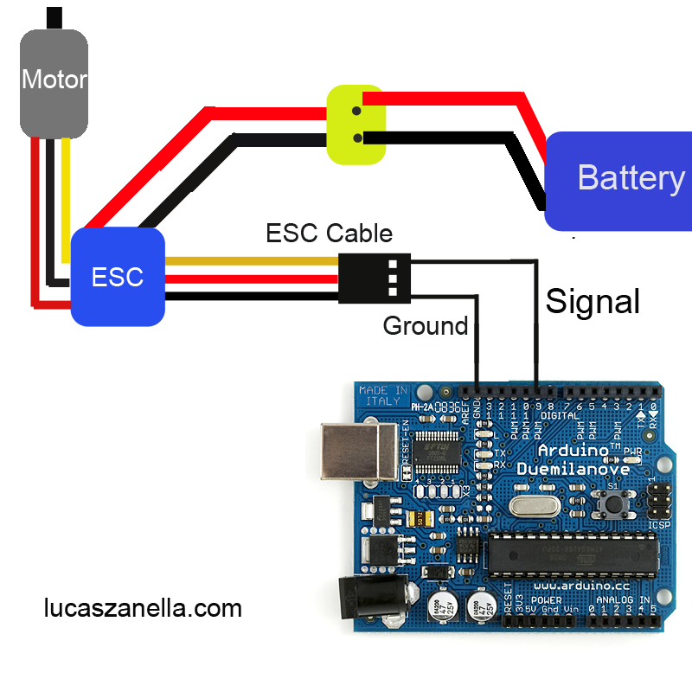

**Hall-Effect sensors**

* The sensor is Honeywell SS360NT SOT-23 Bipolar latch hall effect sensor. More information is on its data sheet.
* Since the rotor has 7 pairs of magnets, the triggering period of a single sensor is every 360/7≈51.43°, and the sensor switches output every 360/7/2≈25.715°.
* The three sensor is evenly located on a circle within an angle of 360/7≈51.43°, which means 360/7/3≈17.14°between adjacent ones.

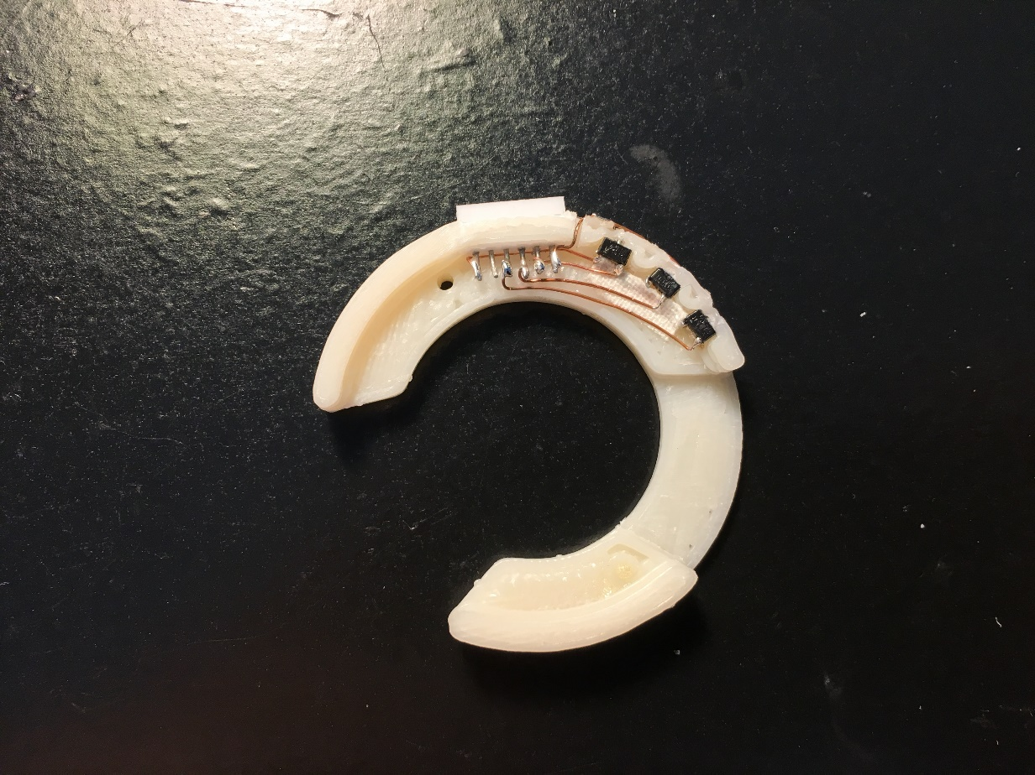

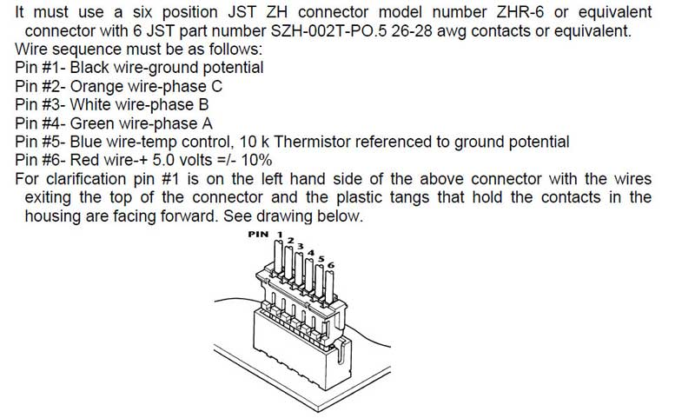

Actual color is different, just refer the number.

Pin5 is not used.

**Connect to a servo tester**

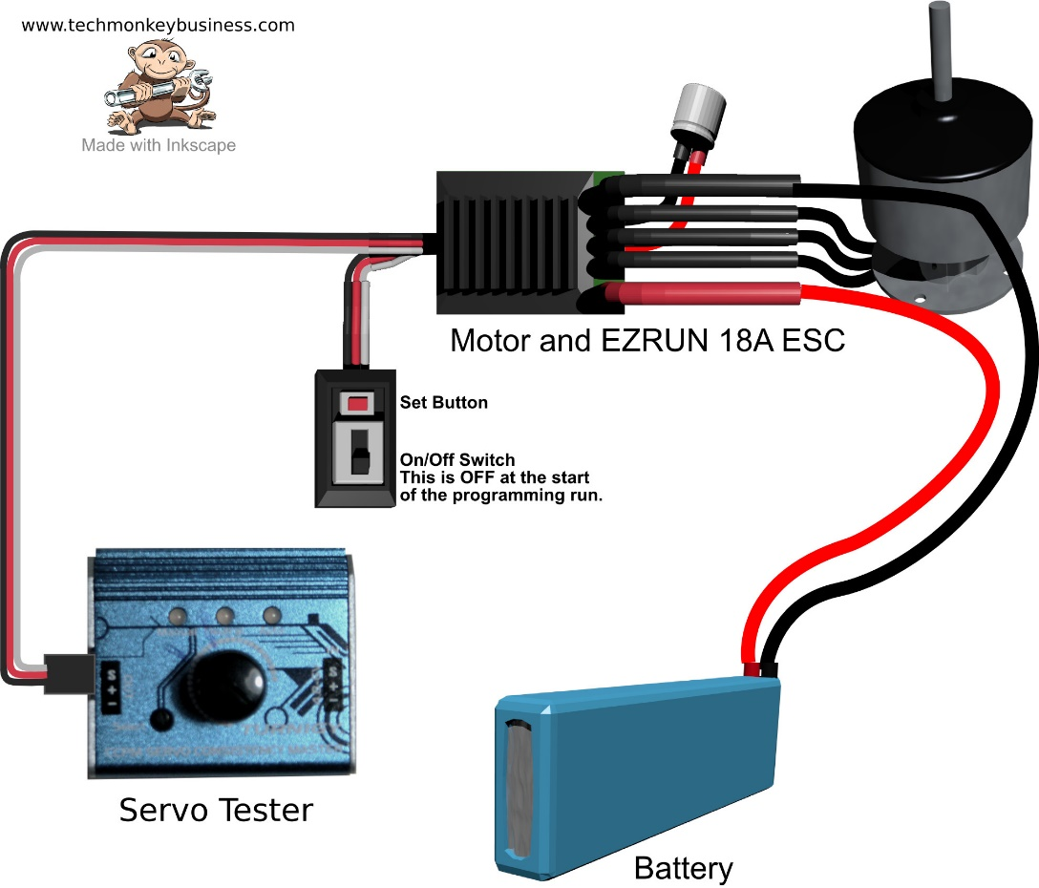

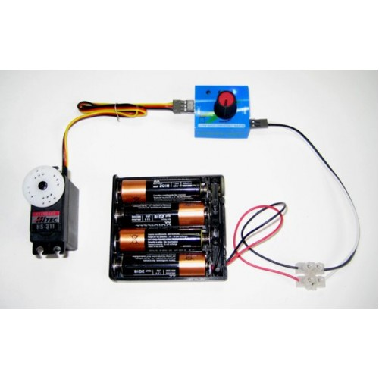

**Other references**

<http://www.techmonkeybusiness.com/calibrating-the-rovs-escs.html>

**NVIDIA Jetson TX1**

GPIO Library Repo:

<https://github.com/NVIDIA/jetson-gpio>

**IDIA Jetson TX1 J21 Header Pinout**

|  |  |  |  |  |  |
| --- | --- | --- | --- | --- | --- |
|  |  |  |  |  |  |
| **Sysfs GPIO** | **Name** | **Pin** | **Pin** | **Name** | **Sysfs GPIO** |
|  | **3.3 VDC** *Power* | 1 | 2 | **5.0 VDC** *Power* |  |
|  | **SDA1** *General I2C #0 Data 3.3.V, I2C Bus 0* | 3 | 4 | **5.0 VDC** *Power* |  |
|  | **SCL1** *General I2C #0 Data 3.3.V, I2C Bus 0* | 5 | 6 | **GND** |  |
| gpio216 | **GPIO_GCLK** *AUDIO_MCLK Audio Master Clock (1.8/3.3.V)* | 7 | 8 | **TXD0** *UART #0 Transmit* |  |
|  | **GND** | 9 | 10 | **RXD0** *UART #0 Receive* |  |
| gpio162 | **GPIO_GEN0** *UART #0 Request to Send* | 11 | 12 | **GPIO_GEN1** *Audio I2S #0 Clock* | gpio11 |
| gpio38 | **GPIO_GEN2** *Audio Code Interrupt* | 13 | 14 | **GND** |  |
| gpio511 | **GPIO_GEN3** *From GPIO Expander (P17)* | 15 | 16 | **GPIO_GEN4** *Unused* | gpio37 |
|  | **3.3 VDC** *Power* | 17 | 18 | **GPIO_GEN5** *Modem Wake AP GPIO* | gpio184 |
| gpio16 | **SPI_MOSI** *SPI #1 Master Out/Slave In* | 19 | 20 | **GND** |  |
| gpio17 | **SPI_MISO** *SPI #1 Master In/Slave Out* | 21 | 22 | **GPIO_GEN6** *From GPIO Epander (P16)* | gpio510 |
| gpio18 | **SPI_SCLK** *SPI #1 Shift Clock* | 23 | 24 | **SPI_CE0_N** *SPI #1 Chip Select #0* | gpio19 |
|  | **GND** | 25 | 26 | **SPI_CE1_N** *SPI #1 Chip Select #1* | gpio20 |
|  | **ID_SDA** *General I2C #1 Data (3.3V), I2C Bus 1* | 27 | 28 | **ID_SCL** *General I2C #1 Clock (3.3V), I2C Bus 1* |  |
| gpio219 | **GPIO5** *Audio Reset (1.8/3.3V)* | 29 | 30 | **GND** |  |
| gpio186 | **GPIO6** *Motion Interrupt (3.3V)* | 31 | 32 | **GPIO12** *Unused* | gpio36 |
| gpio63 | **GPIO13** *AP Wake Bt GPIO* | 33 | 34 | **GND** |  |
| gpio8 | **GPIO19** *AUDIO I2S #0 Left/Right Clock* | 35 | 36 | **GPIO16** *UART #0 Clear to Send* | gpio163 |
| gpio187 | **GPIO26** *(3.3V)* | 37 | 38 | **GPIO20** *Audio I2S #0 Data in* | gpio9 |
|  | **GND** | 39 | 40 | **GPIO21** *Audio I2S #0 Data in* |  |

